Dentist: | Case number:
Patient’s name, age: | Impression date:
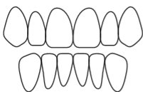
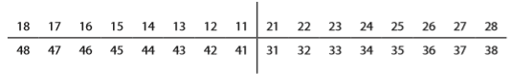
Tooth shade:

Zirconia-Ceramic: 󠄀 󠄀󠄀 | Multilayer zirconia: 󠄀 󠄀󠄀 | PFM: 󠄀 󠄀󠄀
Ceramic margin: 󠄀 󠄀󠄀 | Gradia: 󠄀󠄀 | PMMA: 󠄀󠄀

Case description: | Deadline: expressz: 󠄀󠄀
 | Custom tray:
 | Bite rim:
 | Framework try-in:
 | Bisque try-in:
 | Try-in:
 | Finalization:

